Super Smash Bros

Problem Definition:
This application is a game for two players. The goal of this game is to attack your opponent until they fall off the bottom of the screen. The first person to knock their opponent offscreen 3 times wins.

User Interface Design:
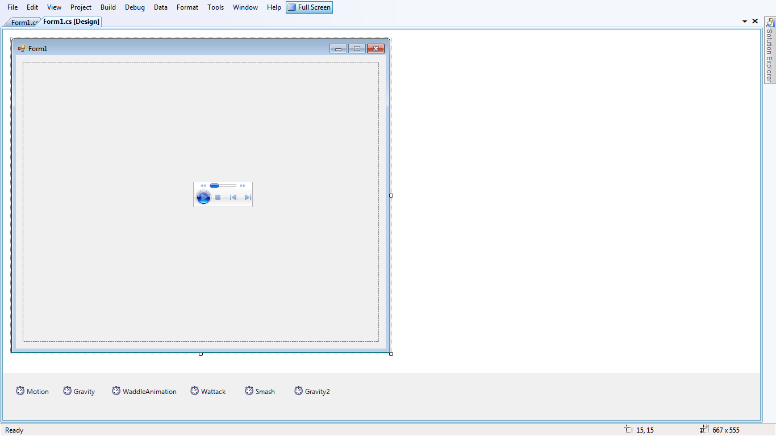
Form1
pnlgame

axWindowsMediaPlayer1

Control type | Property | New Setting | Purpose
Form | Text | SSB ICS3U1 | Main Form
Form | KeyPreview | True . | Main Form
BfPnl | Name | pnlgame | Hold the Game
BfPnl | this.DoubleBuffered | true . | Hold the Game
Windows Media Player | Name | axWindowsMediaPlayer1 | Background Music

General Specifications

General Info:
Application Name: Super Smash Bros. ICS3U1 Edition
Date Created: May/June 2011
Programmer: Ammar Abolebdah

List of Filenames:
Storage Location: Where you download it to.
Project File: gravtest.sln
Form1: Form1.cs

Here is the link to my flowchart: http://www.gliffy.com/publish/2729585/

